A senior design project report on

**“*STAIRCASE ASSISTED CLIMBER*”**

**Bachelor of Engineering in**

Mechanical Engineering

Submitted by

**Submitted by**

|  |  |
| --- | --- |
| Rajat Shetti | 01FE20BME012 |
| Rahul Pawar | 01FE20BME003 |
| Akhilesh Hasbavi | 01FE20BME055 |
| Bharat Devaraddi | 01FE20BME077 |
| Siddu Hebballi | 01FE20BME034 |
|  |  |
|  |  |

Under the Guidance of

**Prof. Mantesh C. Choukimath**



2023-2024

School of Mechanical Engineering

KLE Technological University,

Vidyanagar, Hubballi-580031

**CERTIFICATE**

This is to certify that the Senior Design Project (20EMEW401) report entitled **“*STAIRCASE ASSISTED CLIMBER*”** submitted by Team 19 to KLE Technological University, team members are Rajat Shetti (01FE20BME012), Rahul Pawar (01FE20BME003), Akhilesh Hasbavi (01FE20BME055), Bharat Devaraddi (01FE20BME077) & Siddu Hebballi (01FE20BME034) in partial fulfillment of the requirements for the degree of Bachelor of Engineering in Mechanical Engineering of the KLE Technological University, Hubballi-31 during the academic year 2023-24, is a bonafide record of work carried out by him under our supervision. The contents of the project report, in full or in parts, have not been submitted to any other institute or university for the award of any degree or diploma.

Guide H.O.D

**Prof. Mantesh C. Choukimath Dr. B. B. Kotturshettar**

|  |  |  |
| --- | --- | --- |
| **Sl. No.** | **Name of the Examiners** | **Signatures with date** |
| **1.** |  |  |
| **2.** |  |  |

# ACKNOWLEDGEMENT

The successful completion of any task would be incomplete without mentioning the people who made it possible and whose guidance and encouragement have made our efforts successful.

At the outset, we would like to express our deep sense of gratitude to our guide Prof. **Mantesh C. Choukimath** for making this project successful through their valuable guidance at every stage of the project report.

We also thank Dr. B.B. Kotturshettar for his encouragement in undertaking the task of this project.

We are also thankful to all faculty members of the Mechanical Engineering Department of KLE Technological University, for helping us directly or indirectly in different stages of our project work.

Name Signature

|  |
| --- |
| Rajat Shetti |
| Rahul Pawar |
| Akhilesh Hasbavi |
| Bharat Devaraddi |
| Siddu Hebballi |

# 

# 

# ABSTRACT

This project report presents the includes designing process of a Staircase-Assisted Climber, aimed at enhancing accessibility and mobility for individuals facing challenges in stair ascent. The project unfolds in a systematic manner, starting with an literature survey to understand the existing solutions, challenges, and advancements in mobility assistance devices. The findings from the literature survey form the basis for identifying the objectives and functions of the staircase assisted climber. Following the literature survey, the project delves into the design selection phase, using engineering practices to choose an optimal solution. Various design alternatives are considered and evaluated against criteria such as safety, minimalistic design, controls, reliability. The selection process involves a combination of qualitative and quantitative analyses to ensure a robust and well-informed decision.

Once the design is chosen, the project proceeds to the design and analysis phase. This involves a detailed examination of the selected design through analytical methods. Engineering principles are applied to validate the structural integrity, stability, and performance of the chosen design under different conditions. Finite Element Analysis (FEA) and prototype testing contribute to refining the design and ensuring its compliance with safety standards. The finalization of the design is a culmination of the entire project, integrating feedback from simulations and prototype testing. This phase involves optimizing the design. The report concludes with a detailed overview of the final Staircase-Assisted Climber design, highlighting its features, benefits, and potential for widespread adoption in assisting individuals with mobility challenges. The Staircase-Assisted Climber project showcases a holistic approach to engineering design, incorporating literature insights, rigorous design selection processes, and thorough design analysis. The result is a well-optimized solution that not only addresses the challenges of stair ascent but also adheres to the highest standards of safety, usability, and engineering excellence.

# 

# Table of Contents

ACKNOWLEDGEMENT 1

ABSTRACT 2

Table of Contents 3

1. INTRODUCTION 4

1.1 Overview of Staircase Assisted Climbers? 4

1.2 Problem Statement and Motivation? 4

1.3 Design Objectives and Goals 4

1.4 Mechanisms: The Power Behind the Climb. 5

2. LITERATURE SURVEY: 7

2.1 Introduction: 7

2.2 Literature on patents 7

2.3 OFMC Chart. 13

2.4 Methodology: - 13

3. Design concepts/design calculation 14

3.1 Design concepts generation: - 14

3.2 Design Calculations 18

3.5 Pugh chart:- 22

3.6 Selected Design 22

4. Cad modelling/finite elements analysis 23

4.1 CAD models: - 23

4.1 CAD models: - 24

4.1 CAD models:- 25

4.2 DRAFTINGS:- 26

5. Conclusion 52

6. Future Scope 52

7.0 References 53

# INTRODUCTION

Just imagine the freedom of being able to move around your house without worrying about stairs. For people going up and down stairs can be a challenge that limits their independence and daily activities. There's hope, in the form of staircase-assisted climber’s devices that can make a difference in the lives of those with mobility impairments.

In this report, we explore the design and development of a staircase-assisted climber—a device that has the potential to truly change things for individuals facing mobility challenges. We take a journey, into innovation as we delve into the mechanics, user needs, and engineering principles involved in creating a solution that's both practical and accessible.

Our motivation comes from wanting to empower individuals by giving them back their independence and confidence when it comes to moving around their homes. We envision a world where stairs are no longer an obstacle but instead become pathways toward a fulfilling and connected life.

## 1.1 Overview of Staircase Assisted Climbers?

Staircase-aided climbers function similarly to personal elevators for your staircase, reducing difficult hurdles into simple steps. Imagine effortlessly gliding up and down your steps, the climber adjusting to the curves of your home. These gadgets aren't only for the elderly or those with restricted mobility; they may be a lifesaver for anybody who finds stairs difficult to navigate, whether due to an accident, temporary limits, or simply a desire to save energy. Consider the relief of a recuperating patient rediscovering freedom in their own house or the delight of grandparents effortlessly attending family events upstairs. Climbers who use a stairwell represent the ability of design to improve lives and make every step matter.

## 1.2 Problem Statement and Motivation?

Stairs may be a difficult undertaking for those with mobility issues, leading to social isolation and limited independence. Staircase-aided climbers are a potential alternative, but contemporary designs frequently have drawbacks in terms of pricing, mobility, and use.

To solve these issues, the goal of this project is to create an accessible, user-friendly, and cost-effective staircase-aided climber. This climber will empower those with mobility disabilities with the freedom and independence they deserve by considering user requirements and applying new design techniques.

## 1.3 Design Objectives and Goals

Our objective is to develop a staircase-aided climber that allows people with restricted mobility to restore their freedom and easily explore their houses. We imagine a device that integrates in with the home environment while providing a secure, dependable, and user-friendly experience for everybody.

Our design goals include the following:

**Safety**: A secure seat, strong frame, and emergency stop controls ensure maximum safety for riders of all abilities.

**Ease of Use**: Creating a user experience that is intuitive and effortless, allowing anybody to operate the climber with minimum training or help.

**Reliability**: Build a long-lasting and sturdy climber that can endure everyday use and give years of trouble-free operation.

**Accessibility**: Designing a climber that is accessible to a wide range of users, including those with varied mobility disabilities and physical limits.

**Affordability**: Increasing the climber's accessibility by pursuing cost-effective manufacturing and design options.

## 1.4 Mechanisms: The Power Behind the Climb.

Stairway climbers, often known as stairlifts, are devices that assist persons with mobility issues in ascending and descending stairs. They are a crucial tool for boosting independence and accessibility, especially for individuals who live in multi-story houses or often use stairs.

Several systems may be employed to power stairway climbers, each with its own set of pros and downsides. Here's a quick review of several popular mechanisms:

* + 1. **Planetary wheel mechanism stair-climbing wheelchair:**

Consider a wheelchair that can simply glide up and down stairs, completely changing your life. To overcome those formidable hurdles, this unique design incorporates a planetary wheel system, similar to a set of intermeshing gears. As you approach the stairs, the wheels fluidly modify their design, allowing you to easily navigate each step. It's like having your own personal escalator at your disposal, offering up new avenues for movement and independence.

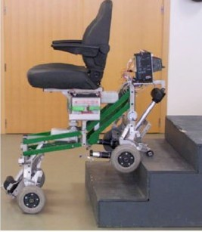

Figure 1.1

1. **Tracked mechanism stair-climbing wheelchair**

The tracked mechanism stair-climbing wheelchair easily ascends steps, allowing users with mobility problems to access their surroundings without constraints.

This ingenious wheelchair effortlessly conquers any staircase, changing formerly insurmountable hurdles into avenues of freedom. It is equipped with sturdy tracks and a powerful engine. Its simple controls and comfy seats provide a safe and easy ascension, encouraging independence and self-reliance.

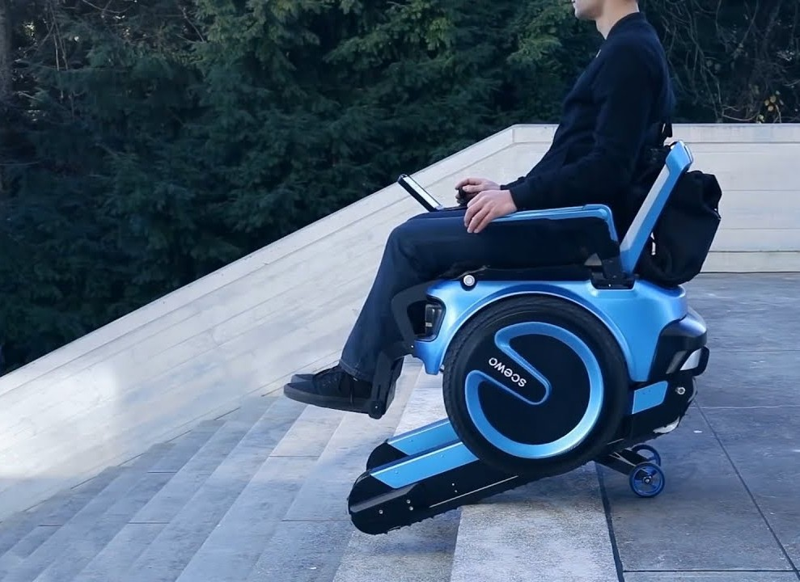 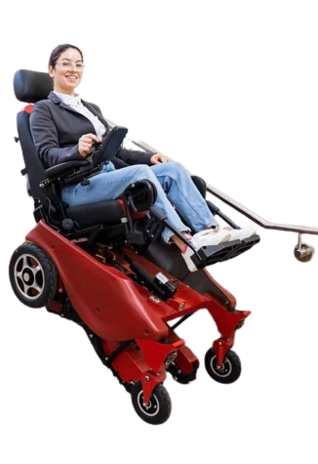

Figure 1.2 Figure 1.3

1. **Auxiliary stair-climbing wheelchair**:

Consider a future in which wheelchairs can easily negotiate any stairway, allowing people to go wherever their lives lead them. With the introduction of the Stair-Conquering Wheelchair, a ground-breaking technology that converts regular wheelchairs into stair-climbing champions, this goal is becoming a reality.

This wheelchair, equipped with a clever auxiliary mechanism, simply ascends and lowers stairs, giving individuals who rely on mobility assistance fresh independence and freedom. No staircase is off-limits with this unique technology, whether it's reaching the top level of an apartment building or taking a stroll in the park.

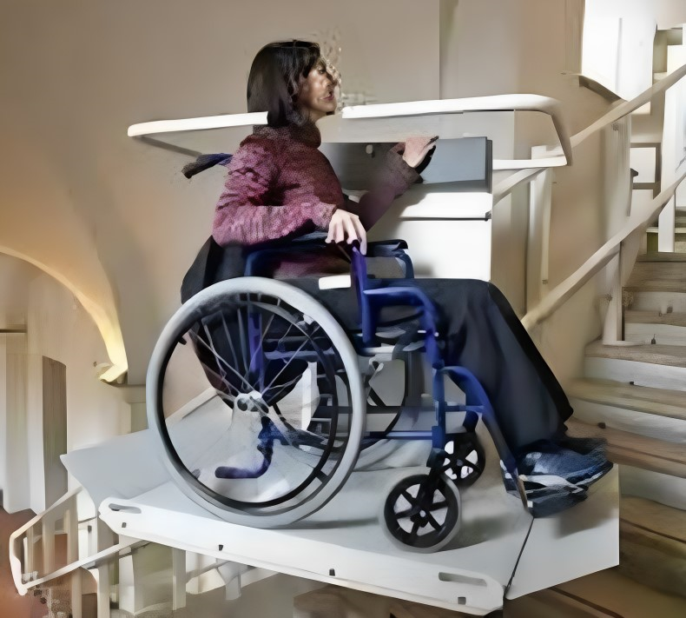

Figure 1.4

# 

# 2. LITERATURE SURVEY:

## 2.1 Introduction:

The scope, goal, and relevance of the study are often outlined in the introduction to a literature survey. It gives an overview of existing research in the discipline, indicating gaps or areas that require more investigation. It should clarify the context, importance, and aims of your survey, as well as guide readers on what to expect in terms of topics covered and survey format.

## 

## 2.2 Literature on patents

1. **Improvements for Power-assisted Three-wheel Carrier Cart with Stair-climbing Ability.** Author: **Toru Ishii-Japan**. (2022)

We conducted comparison trials with a three-wheeled carrier-cart to assess the performance of the suggested power-assist control mechanism. The cart had either a standard stair-climbing mechanism or the suggested constant output device. Experiments were carried out on level terrain, ascending and descending steps. We suggest a new power-assist control approach that employs a constant output mechanism to overcome this issue. This approach ensures a constant power supply to the wheels independent of the incline of the cart. This guarantees that the cart assists the user continuously throughout both climbing and descending operations, lowering the user's load and enhancing operability. Existing power-assisted carts generally use a stair-climbing device that holds the wheels at one end while lifting and lowering the other end to navigate steps. While this method works well for ascending stairs, it can be time-consuming and inefficient for descending steps. Users frequently need to use more power to control the cart's fall, especially on steeper hills. Power-assisted carts have emerged as a viable way to alleviate user load, particularly while negotiating stairs. Traditional power-assist methods, on the other hand, frequently struggle with descending stairs, resulting in higher user effort and decreased operability. This research tackles this issue by providing a novel power-assist control mechanism and testing its effectiveness.

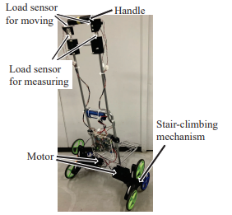

Figure 2.1

**2. A novel design of the intelligent stair-climbing wheelchair.**

Author: **Jingcheng Sun** (2020)

Individuals with restricted mobility have substantial challenges while navigating inclines and stairs, and they frequently rely on help or assistive technology. Traditional stair-climbing wheelchairs are frequently big, heavy, and costly, making them unpopular. To overcome these restrictions, this study develops a revolutionary transformable wheelchair (TW) design that provides weight-space economy, increased safety, and improved user comfort.

The suggested transformable wheelchair design tackles these constraints by combining a number of novel features:

**Weight-Space Efficiency**: The TW has a transformable wheel design that allows it to switch between normal wheelchair mode for flat areas and stair-climbing mode for tackling stairs. This one-of-a-kind mechanism decreases the total weight and size of the wheelchair, improving portability and convenience.

**Friction-Reducing Geometry**: The transformable wheel design features geometric aspects that reduce friction and improve grip on slippery terrain, especially while ascending stairs. This eliminates the possibility of slippage and provides safe and dependable operation even in difficult circumstances.

**Stand-Up Assistance System**: The TW has a stand-up assistance system to improve user comfort and independence.

The suggested transformable wheelchair design is a significant improvement in wheelchair technology that addresses the constraints of traditional stair-climbing wheelchairs. The TW has the potential to change mobility for those with restricted mobility by merging weight-space economy, greater safety, and improved user comfort.

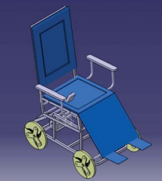

Figure 2.2

**3.Research on multifunction-al integrated intelligent stair-climbing chair based on ergonomics.**

**Author: Man Zhang, Jingde Huang, and Chenbo Jiang (2021)**

Mobility issues are a serious barrier for many people, particularly those who rely on wheelchairs for everyday mobility. Staircases can be particularly difficult to navigate, necessitating the aid of others. To solve this issue, a self-help intelligent ladder climbing chair with higher freedom and mobility has been designed. The ergonomic design of the chair promotes user comfort and safety. Its revolutionary ladder system allows users to autonomously ascend and descend staircases, eliminating their dependency on external help. To simplify design optimization and assure structural integrity, UG software was used to generate a three-dimensional model of the chair. The self-help intelligent ladder chair intends to close the supply-demand gap in the ladder mechanism industry. The chair's performance was evaluated using finite element analysis. Sales of the self-help intelligent ladder chair are expected to rise to 4800 yuan (about $670 USD) per wheelchair, offering a huge possibility for expansion. The chair is positioned to have a significant effect on the lives of wheelchair users, with an expected annual sales growth rate of 20.8% over the next 4-5 years. The self-help intelligent ladder climbing chair is an innovative solution to wheelchair users' mobility issues. Its ergonomic form, practicality, and low cost make it an excellent tool for increasing independence and quality of life. The chair's anticipated market expansion illustrates its ability to benefit both the wheelchair business and society as a whole.

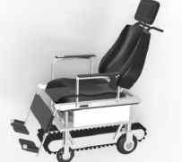

Figure 2.4

**4. Designing and Analysing staircase lift mechanism**

**Author: Timur Choban Khidir, Abbas Mohammed Ismael & Ayaz Aydin Abduljabbar. (2017)**

Staircase lifts have become an indispensable help for the elderly and disabled, allowing them more mobility and independence in their homes. The Solidworks program was used in this study to conduct a detailed investigation of a staircase lift mechanism, concentrating on its structural integrity and performance under various load circumstances.

Solidworks software was used to model the staircase lift, which included a chair, rail, D.C. motor, and gear system. The study concentrated on calculating the von Mises stress, strain, deformation, and factor of safety for a maximum user weight of 95 kilograms. A square rail section was used, and safety zones for the rack and pinion gear were designed.

According to the findings of the investigation, the staircase lift mechanism could securely handle a maximum user weight of 95 kilos. Von Mises stress, strain, and deformation values stayed within acceptable ranges, and the factor of safety was significantly higher than the needed minimum. The rack and pinion gear's safety zones were also properly established, assuring the proper operation and protection of these crucial components. The study evaluated the dynamic behaviours of the staircase lift mechanism in addition to the structural analysis. The research took into account elements such as motor torque, chair weight, and friction between the chair and rail. Overall, the investigation showed that the staircase lift device was well-designed and capable of securely transporting individuals up and down steps without the usage of elevators. Solidworks software was used to analyze the device's structural integrity, performance, and dynamic behavior, assuring its fitness for its intended function.

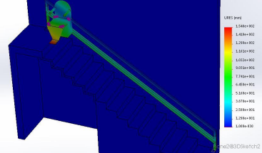

Figure 2.5

1. **Smart stair lifts for disabled and elderly**

**Author: B. Pavan Kumar (2018)**

This project aims to create an indoor and outdoor stair lift, a mobile chair-like mobility device that enables safe and comfortable access for the elderly. The single rail stair elevator will reduce production costs and construction time, making it a cost-effective solution to overcome unique challenges faced by people on stairs. This project aims to create an indoor and outdoor stair lift, a mobile chair-like mobility device that enables safe and comfortable access for the elderly. The single-rail stair elevator will reduce production costs and construction time, making it a cost-effective solution to overcome unique challenges faced by people on stairs. 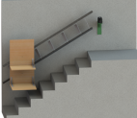

Figure 2.6

1. **Wheelchair stair assist apparatus**

**Author: Steven Rembos, Hinsdale, IL (US); Rick Guindon, Brookfield, WI (US); Kenneth Muderlak, Milwaukee, WI (US); Todd J. Muderlak, Whitefish Bay WI (US) (2011)**

Staircases may be difficult for wheelchair users to navigate, frequently necessitating the aid of others or limiting their access to particular places. To overcome this issue, an ingenious gear has been devised to convert regular wheelchairs into stair-climbing devices, giving wheelchair users additional independence and movement. The device includes a motorized component that interacts with stair steps, allowing the wheelchair to glide up and down stairs effortlessly and confidently. This motorized technology removes the need for bumps and jolts, resulting in a smooth and safe ride. In addition, the gear has a headrest and swivel handlebars to improve comfort and control when stair climbing.

The adaptability and retrofit ability of this device are significant advantages. It is readily attached onto a normal wheelchair or any chair, allowing users to connect and detach the device as needed without having to change their existing wheelchair. Because of its versatility, the device provides a practical and accessible option for a wide spectrum of wheelchair users. The design of the device stresses safety and stability, ensuring that the wheelchair stays stable during the stair-climbing procedure. The secure housing and attachment mechanism secures the device to the wheelchair, avoiding undesired movement or disconnections. Furthermore, while not in use, the equipment does not hinder the wheelchair's usual mobility, allowing for smooth transitions between stair climbing and ordinary wheelchair use.

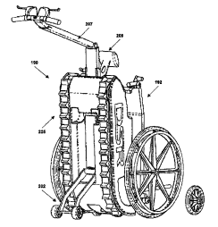

Figure 2.7

## 2.3 OFMC Chart.

|  |  |  |  |
| --- | --- | --- | --- |
| OBJECTIVES | FUNCTIONS | MAINS | CONSTRAINTS |
| Efficient Personal Transportation. | Personal Transportation. | Balancing. | Stability and Balance. |
| Compact and Portable. | Eco-Friendly Commuting. | Safety Features. | Safety Concerns. |
| Last-Mile Solution. | Compact and Portable. | Steering. | Limited Range. |
| Agility and Maneuverability. | Self-Balancing. | Acceleration and Deceleration. | Charging Infrastructure. |
| Fun and Recreation. | - | Braking. | Limited Payload. |

## 

## 2.4 Methodology: -

The development of a staircase-assisted climber involves a thorough design process that includes conceptualization, modelling, analysis, and optimization. This methodology focuses on the 3D modelling aspects, providing a structured approach to creating a virtual representation of the climber. By utilizing CAD software, simulation tools, and visualization techniques, this methodology enables designers to evaluate the climber's effectiveness and make informed design decisions without the need for physical prototyping.

1. **Define problem statement and requirements:** Clearly outline the intended purpose of the staircase assisted climber, the target user group, and the specific functionalities it should provide. Consider factors like weight capacity, maximum stair inclination, simplicity, and safety features**.**
2. **Conceptual design and research:** Conduct thorough research on existing staircase assisted climber designs, their strengths, weaknesses, and potential improvements. Explore various mechanical concepts, power transmission mechanisms and create design alternatives. Use proper criteria for finalising design concepts.
3. **Detailed 3D modelling:** Utilize CAD software to create detailed 3D models of the climber's structure, components, and operation. Focus on creating accurate and precise representations of the design.
4. **Kinematic and dynamic analysis:** Utilize simulation software to analyze the climber's movement, forces, and stresses during operation. Evaluate the kinematics and dynamics of the climber's motion, ensuring smooth and safe operation.
5. **Stress analysis:** Usinganalysis toolsapply load to evaluate the stress distribution, deflection, and stability of the climber's components. Ensure structural integrity and prevent failures in the virtual model.
6. **Design refinement and optimization:** Based on the analysis results, and design considerations, refine and optimize the 3D model to improve safety.
7. **Visualization and presentation:** Prepare renderings/ animations, and visualizations of the 3D model to showcase the climber's design and functionality.
8. **Documentation and reporting:** Prepare comprehensive documentation, including detailed 3D model files, simulation reports, analyses, and design iterations, to capture the design process and findings.

# 3. Design concepts/design calculation

## 3.1 Design concepts generation: -

1.

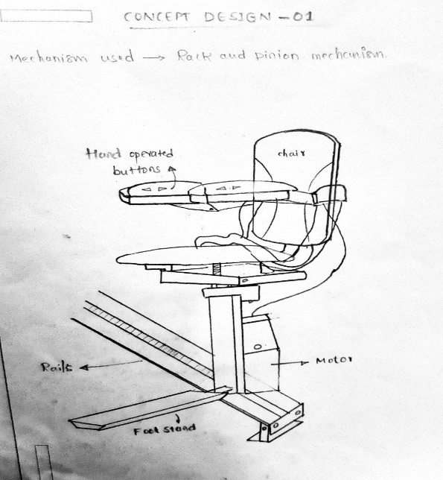

Figure 3.1.1

2.

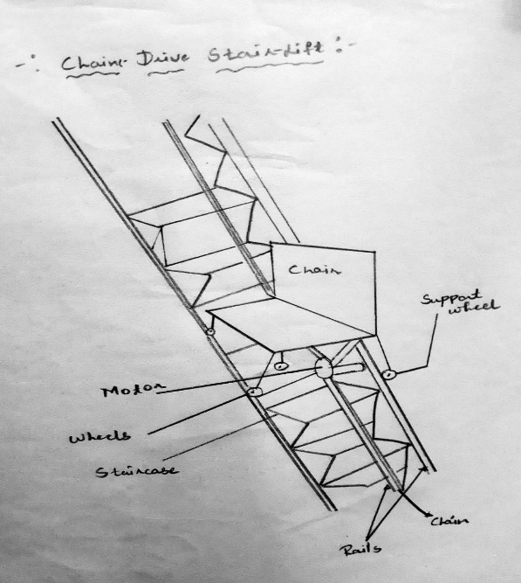

Figure 3.1.2

3.

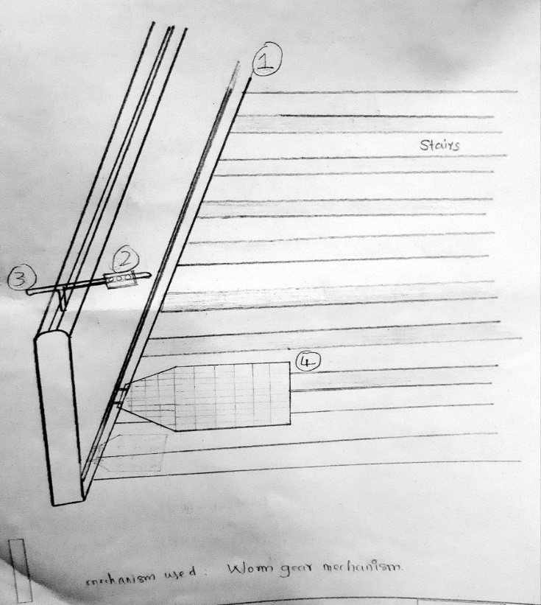

Figure 3.1.3

4.

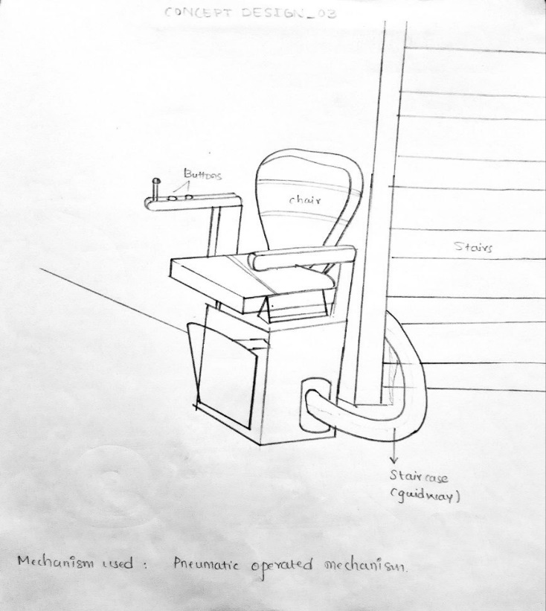

Figure 3.1.4

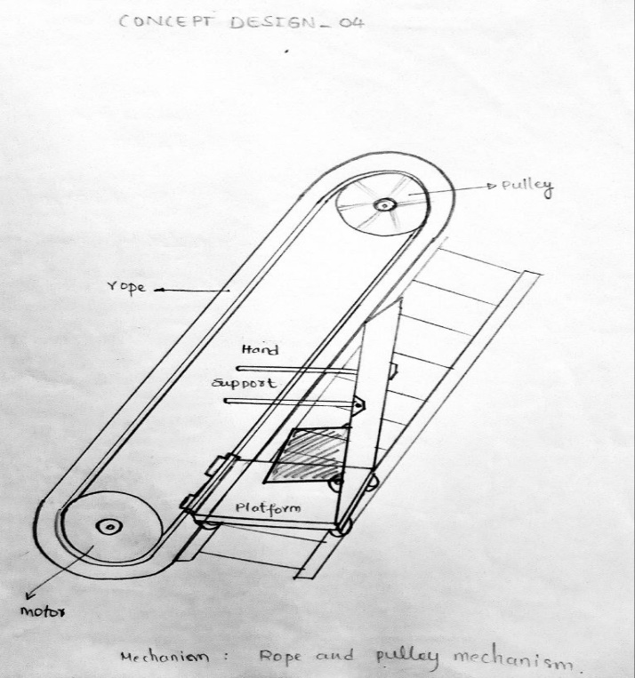5.

Figure 3.1.5

6.

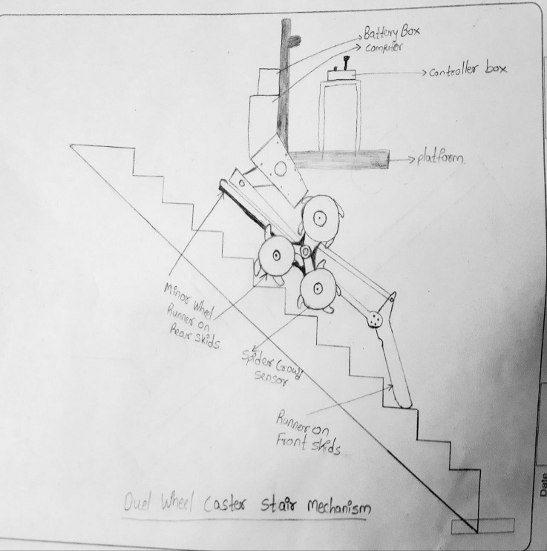

Figure 3.1.6

## 3.2 Design Calculations

**Staircase Calculation**

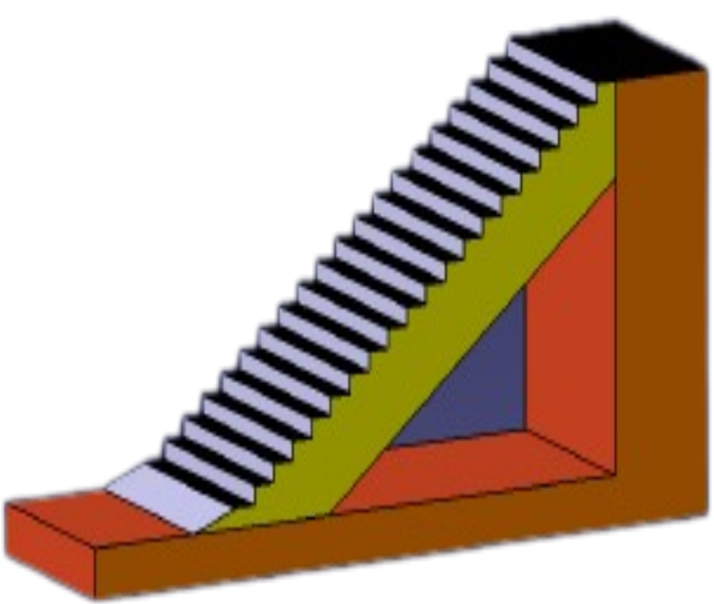

Rise = 7 inch, Run = 11 inch Figure 3.2.1

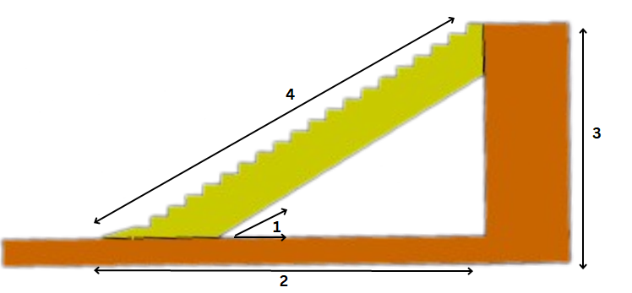

Figure 3.2.2

1. Angle = 32.47 degree 3. Stringer Height = 11 ft 7.61 inch

2. Total Run = 220 inch 4. Stringer Length = 21 ft 8.56 inch

**Selected** **Staircase Calculation.**

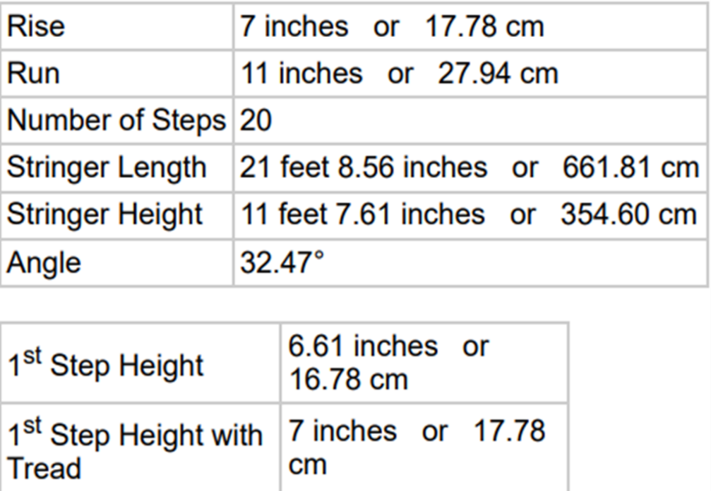

**Methodological Chart.**

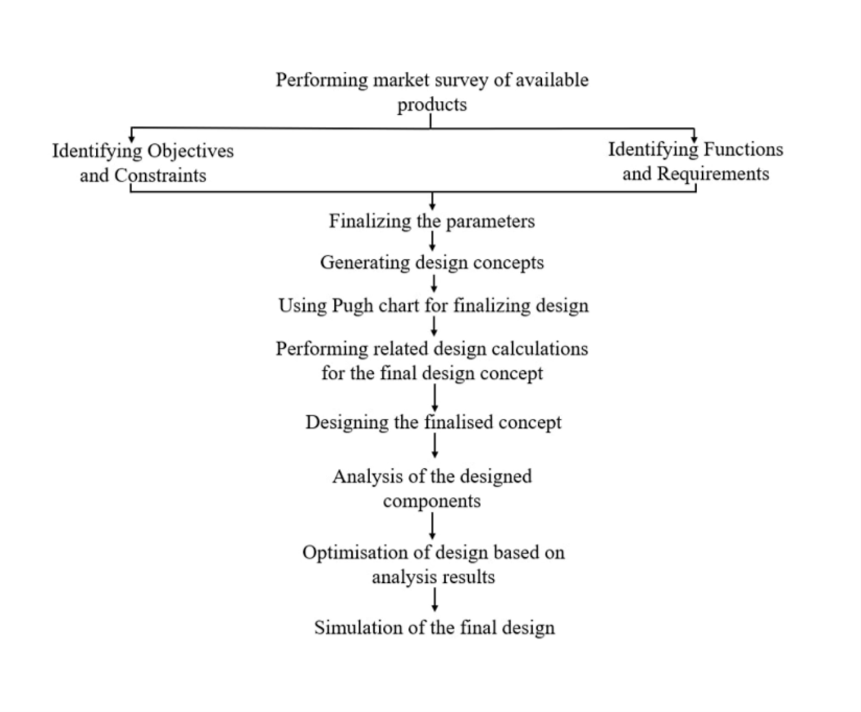

**3.3 The maximum load that can be carried by motor**

1. Efficiency of the motor, 𝜂𝑚 =72%
2. Maximum Speed =2750 rpm
3. Gear Ratio = 1:6
4. Actual Speed = 2750/6 =458.334 rpm
5. Gear reduction ratio by worm = 14:1
6. Speed at carriage = 458.334/14 =32.73 rpm

Now,

The maximum load that can be carried by motor:

P*𝜂𝑚= F*v

250 W *0.72 = F *{(π∗d∗N)/ 60}

180 =F * {(𝜋 *0.058*32.73)/60}

F = 1810.687 N

But,

F=mg

mg=1810.678 N

m = 1810.678*9.81

= 184.57 Kg

**3.4 Power required for average load carrying:**

1. The mass of the carriage, motor, gearbox, and chair is about =15 kg

2. Average mass to be lifted =120Kg

3. Total mass, m = (Mass of the carriage, motor, gearbox, and chair +Average: mass to be lifted)

= (120+15) Kg

=135 Kg

4. Total Weight W=mg

                             = (135*9.81)

                               =1324.35 N

 (Coefficient of Friction for ball bearing 𝜇=0.002)

**Force required,** F = Wsin 𝜃

                            = 135*9.81* sin 40°

                               = 581.275

                           = 851.275 N

**Velocity,**

              V=(𝜋∗𝐷∗𝑁)/60

               = 3.141* 0.058*32.73

                = 0.0994

               = 0.1 m/s

**Power,**

               P = (𝐹*𝑣)/𝜂𝑚

                  = (851.275*0.1)/0.72

                 = 118.23 W.

## 3.5 Pugh chart: -

TABLE 3.1.1

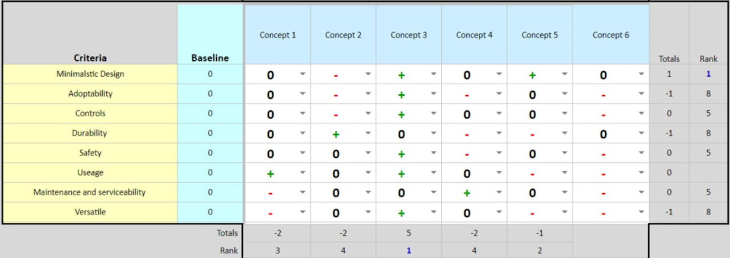

## 3.6 Selected Design

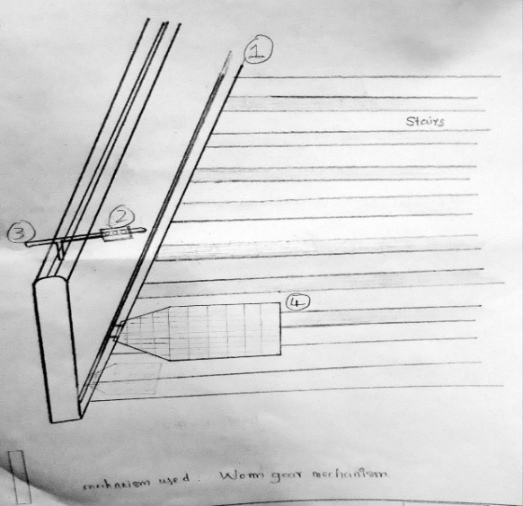

Figure 3.1.3

1. Support rails for stability and handholds.
2. Call buttons to summon and control the lift.
3. Handle support for balance.
4. Platform with ample space and non-slip surface.

# 4. Cad modelling/finite elements analysis

## 4.1 CAD models: -

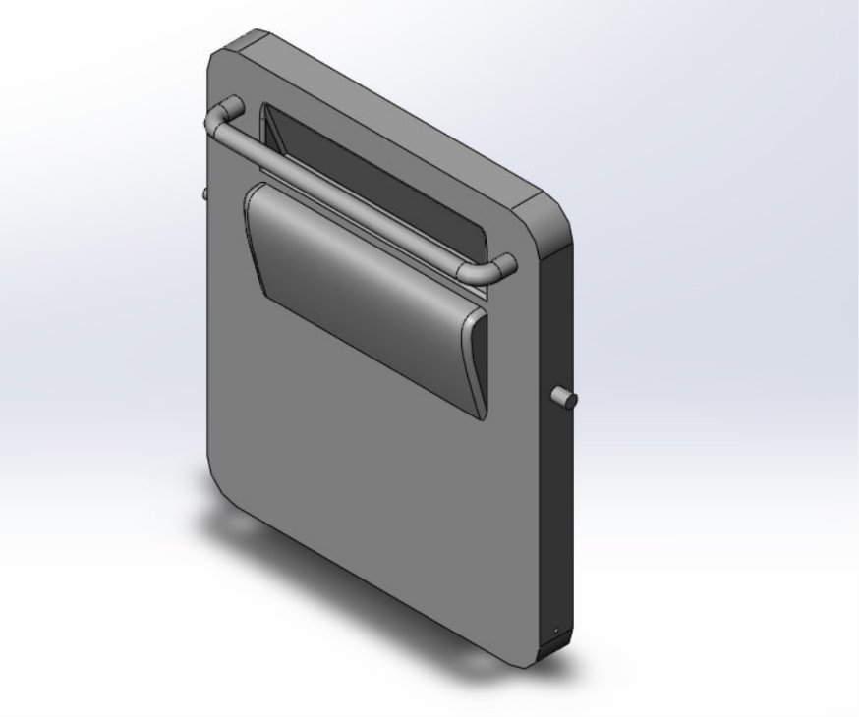

Figure 4.1.1 Plateform

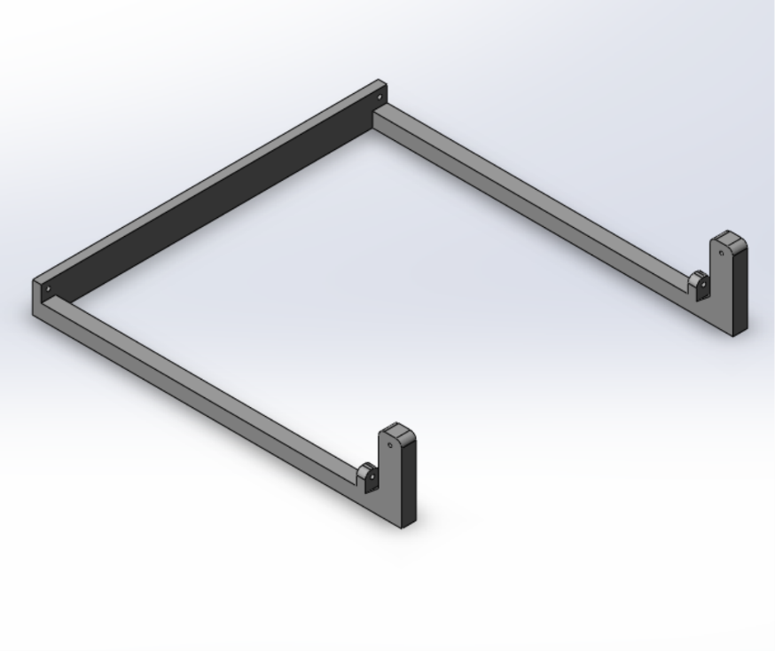

Figure 4.1.2 Base

## 4.1 CAD models: -

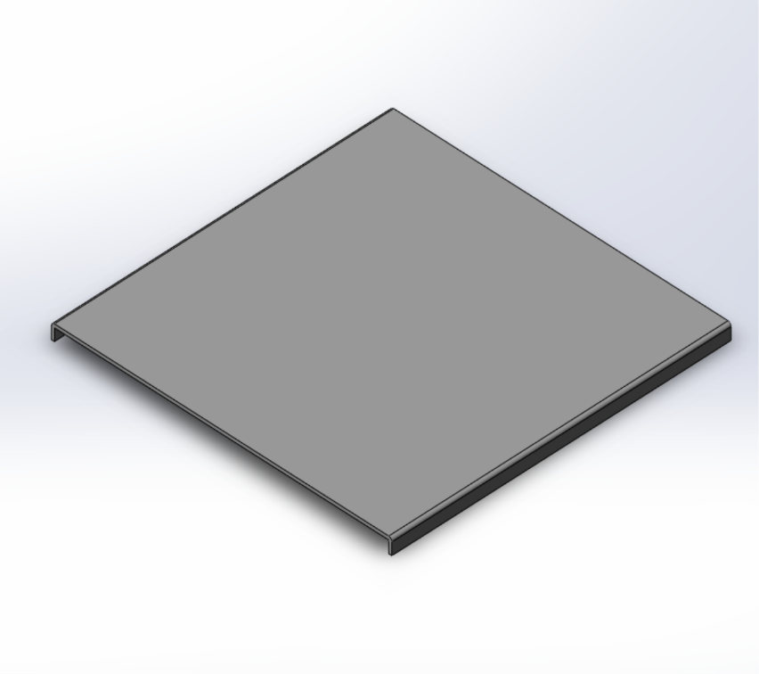

Figure 4.1.3 Plate.

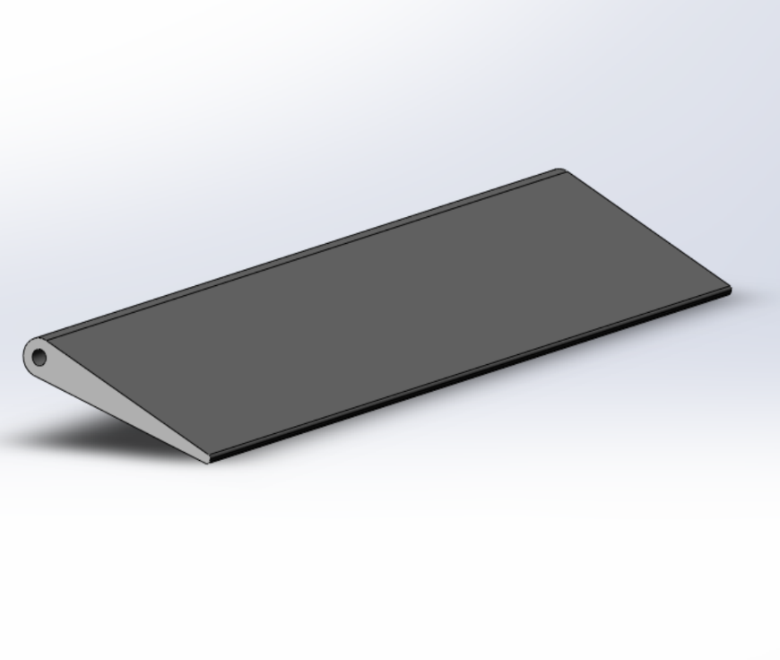

Figure 4.1.4 Side

## 4.1 CAD models: -

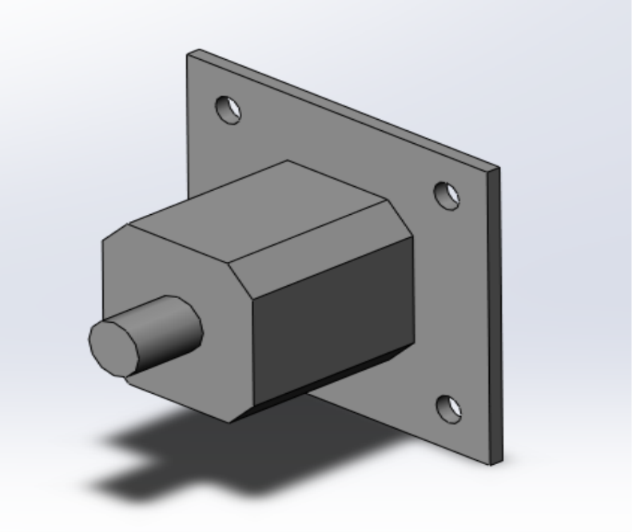

Figure 4.1.5 MOTOR.

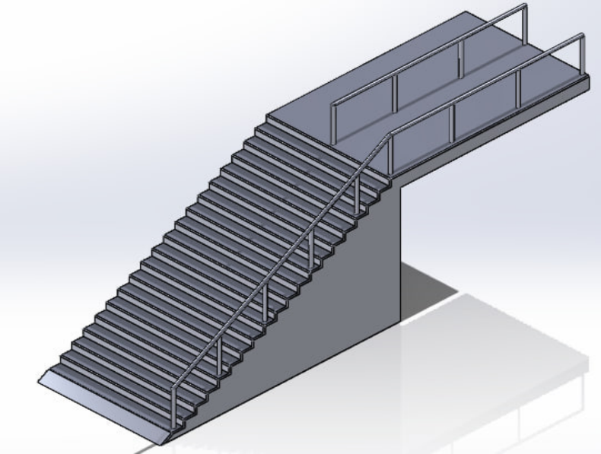

Figure 4.1.5 Stairs and railings.

## 4.2 DRAFTINGS: -

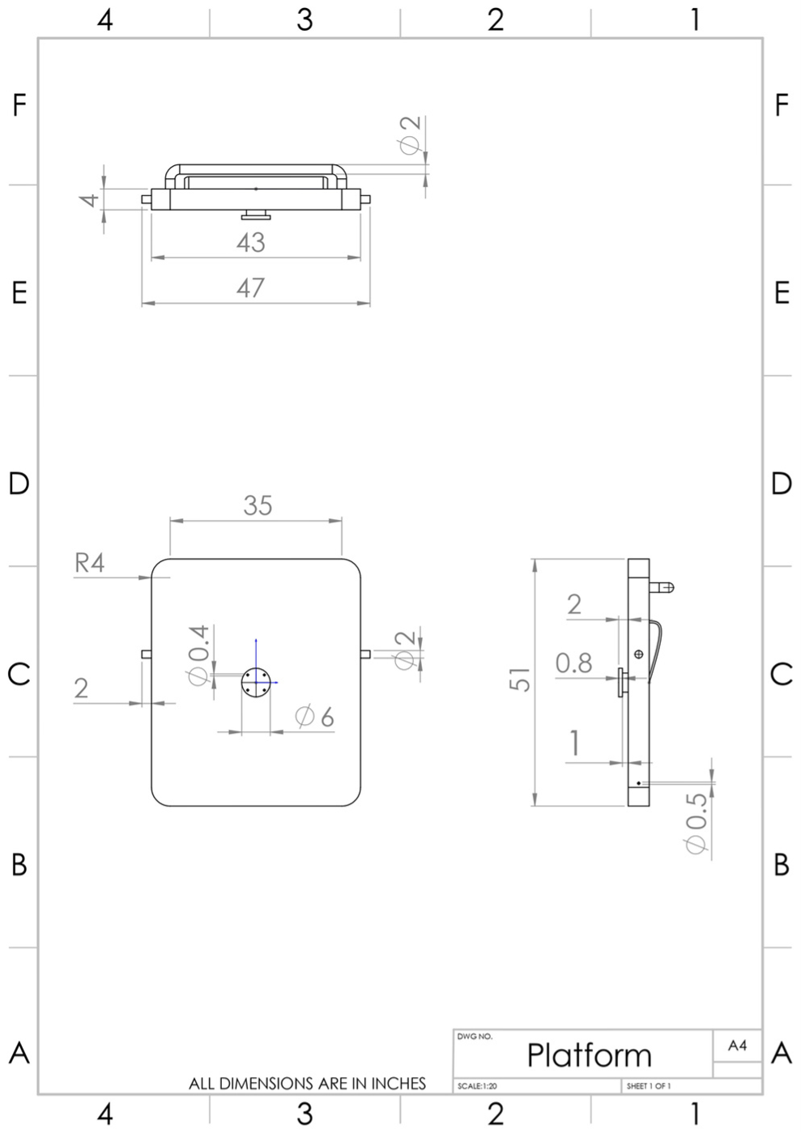

Figure 4.2.1

**4.2 Drafting**

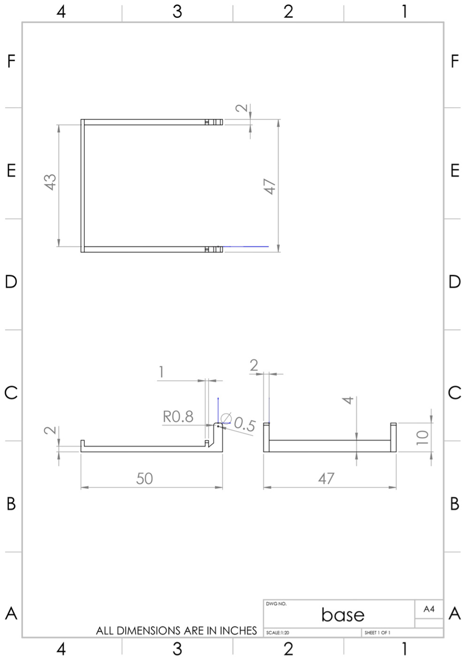

**Figure 4.2.2**

**4.2 Drafting**

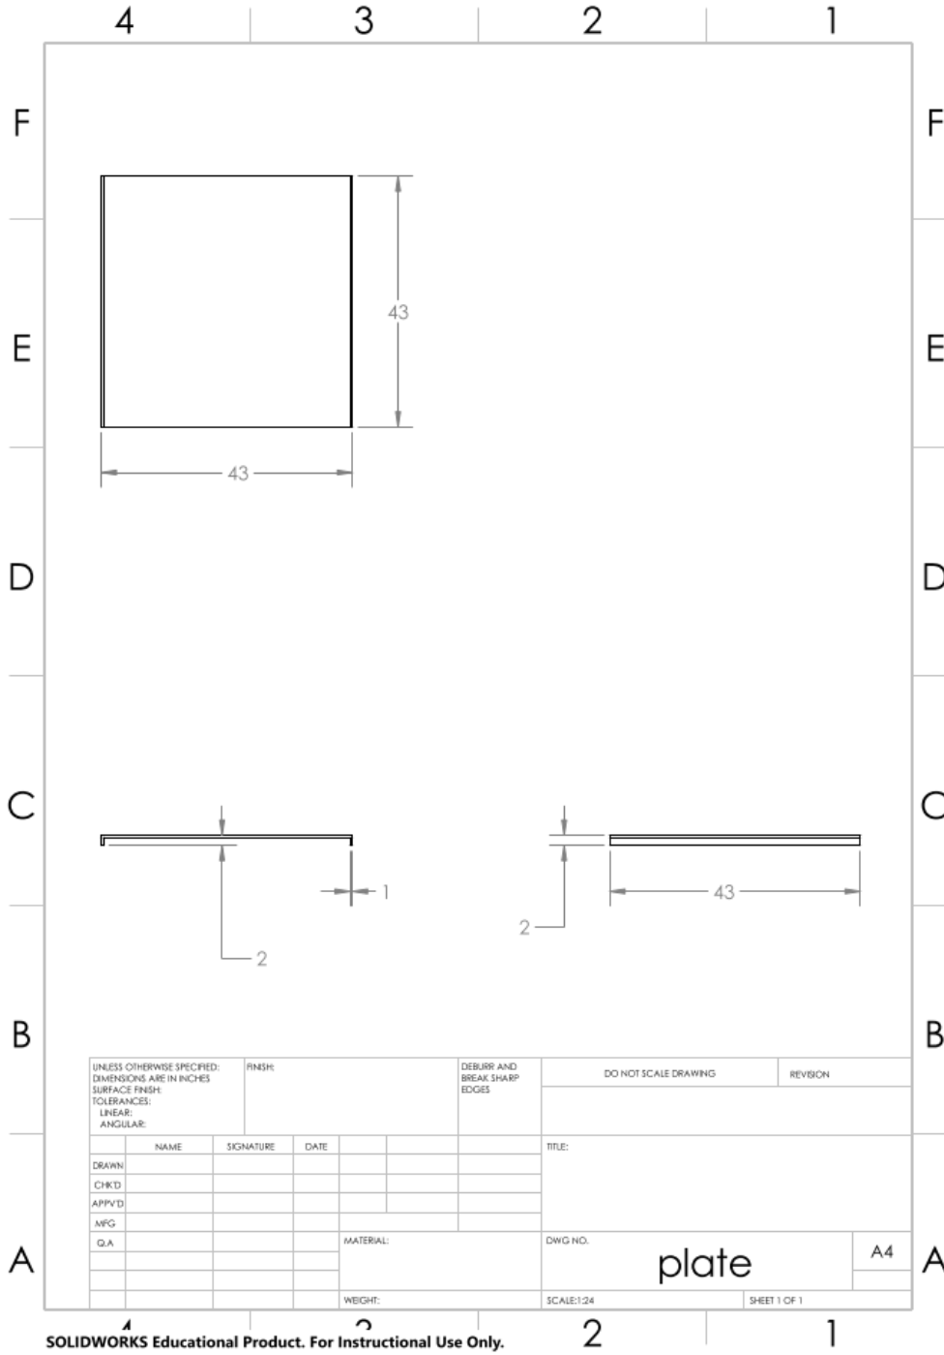

**Figure 4.2.3**

**4.2 Drafting**

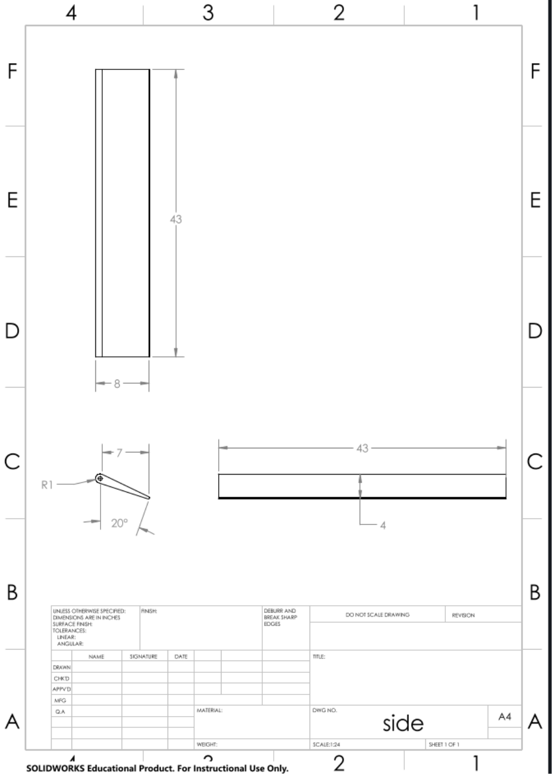

**Figure 4.2.4**

**4.2 Drafting**

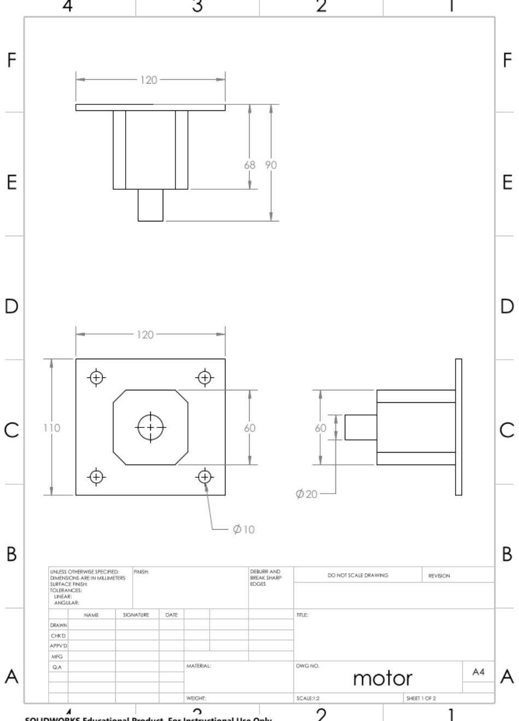

**Figure 4.2.4**

**4.2 Drafting**

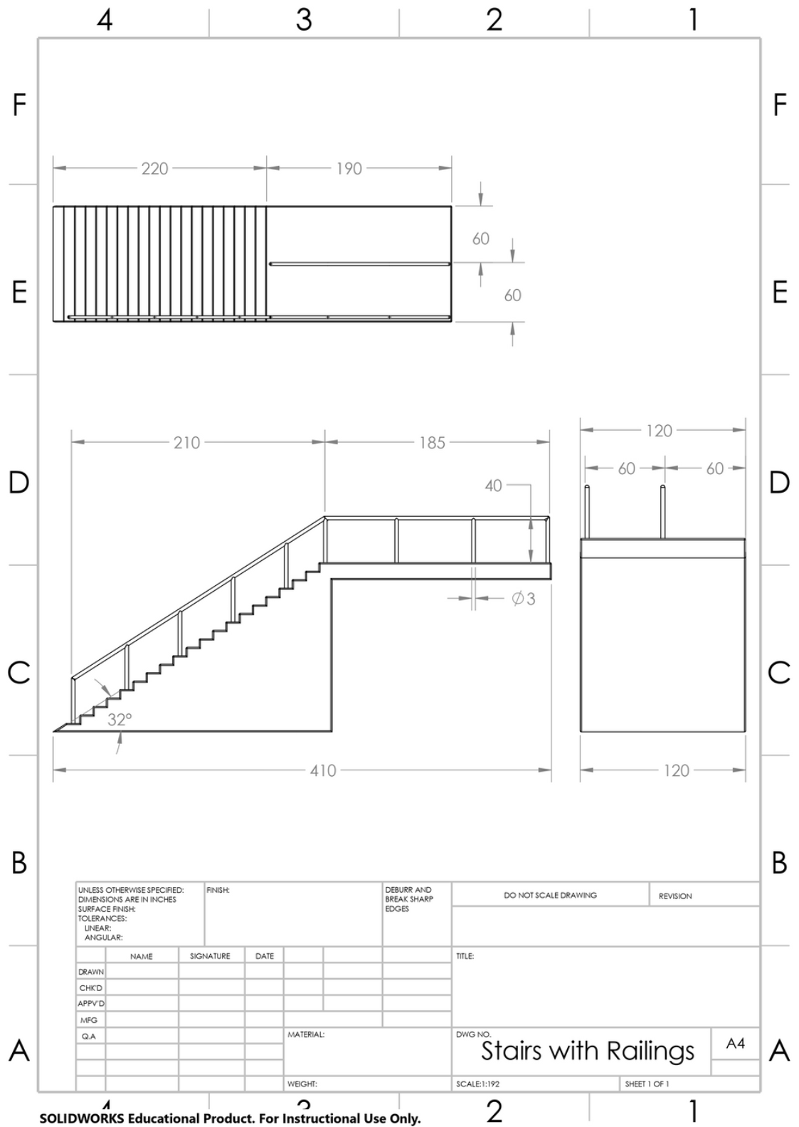

**Figure 4.2.5**

Assembly Drawing

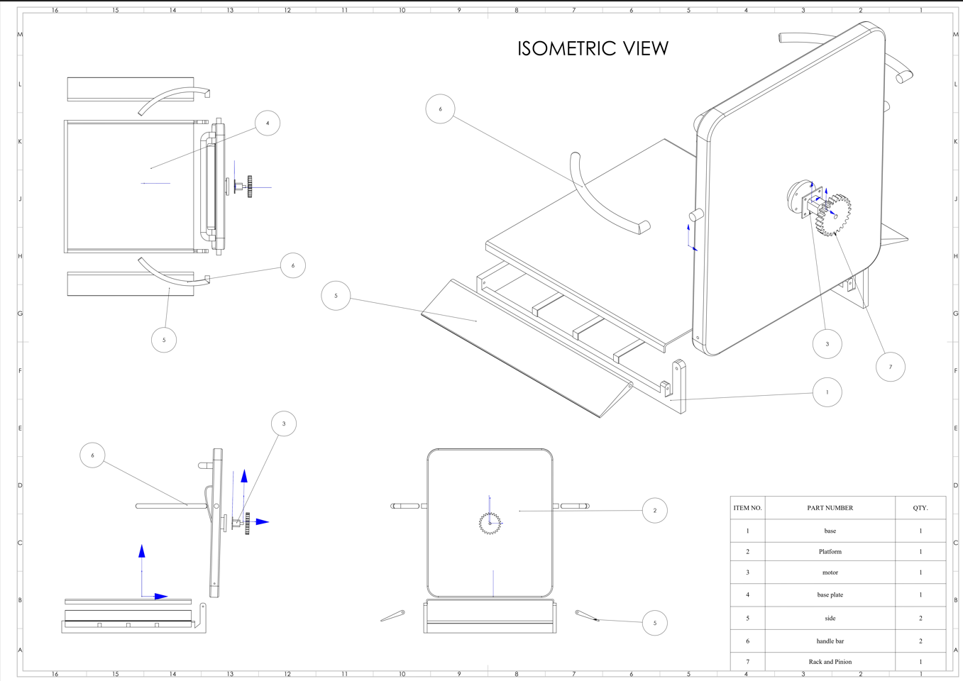

**ISOMETRIC VIEW:**

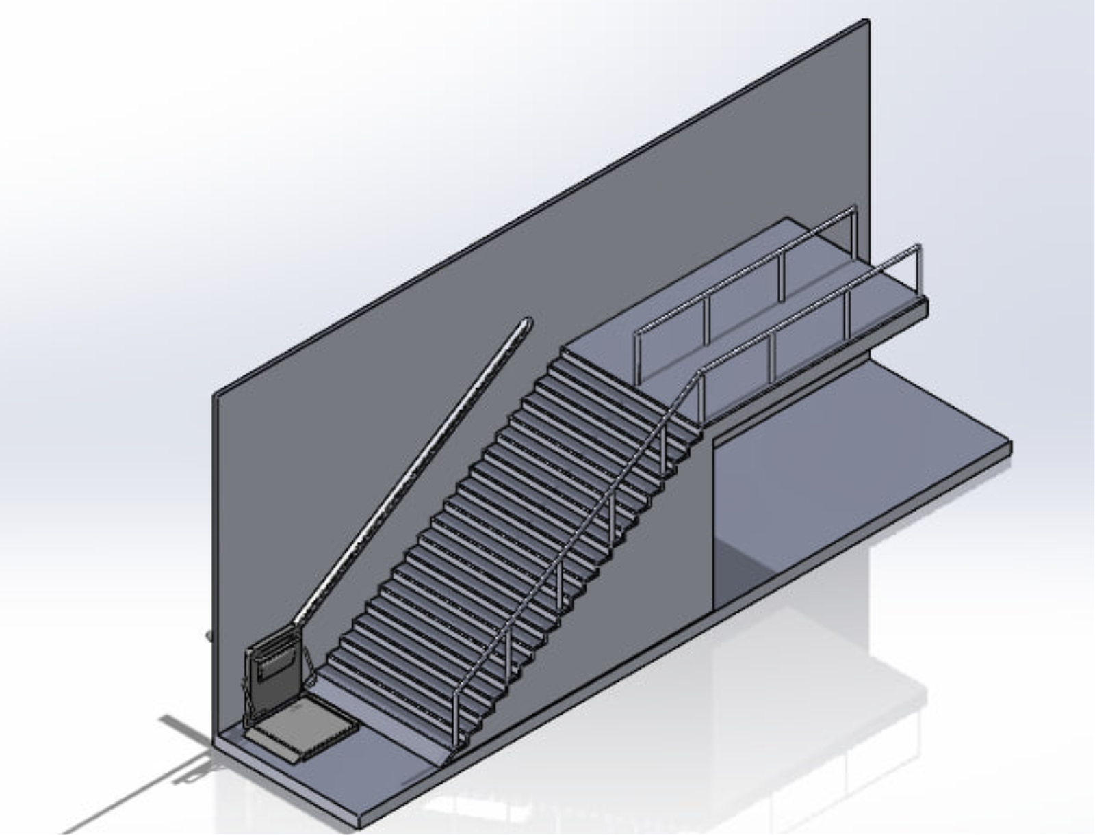

**Material selected - Aluminium 6061-T6**

**MATERIAL PROPERTIES:**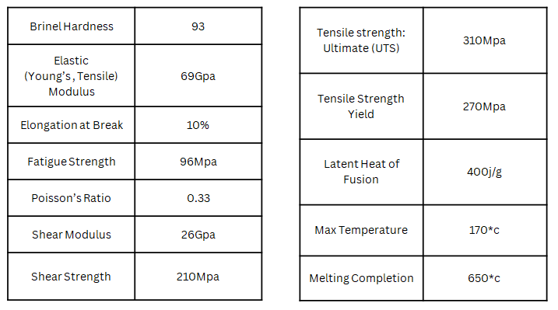

**4.3 Finite Element Analysis**

**MESH FOR FULL BODY**

We carried out the static structural analysis for the CAD model after conducting a meshing of element size 6mm and a mixed type of mesh was obtained with **Nodes – 1168031** and **Elements - 407479** respectively.

## 

We gave the following boundary conditions of the chassis are, the total force applied on the base plate is **1470 N**.

* The total force applied on the handle is **200N.**
* Fixed support is given to the hinge.
* Cylindrical support is given to handle support.

`

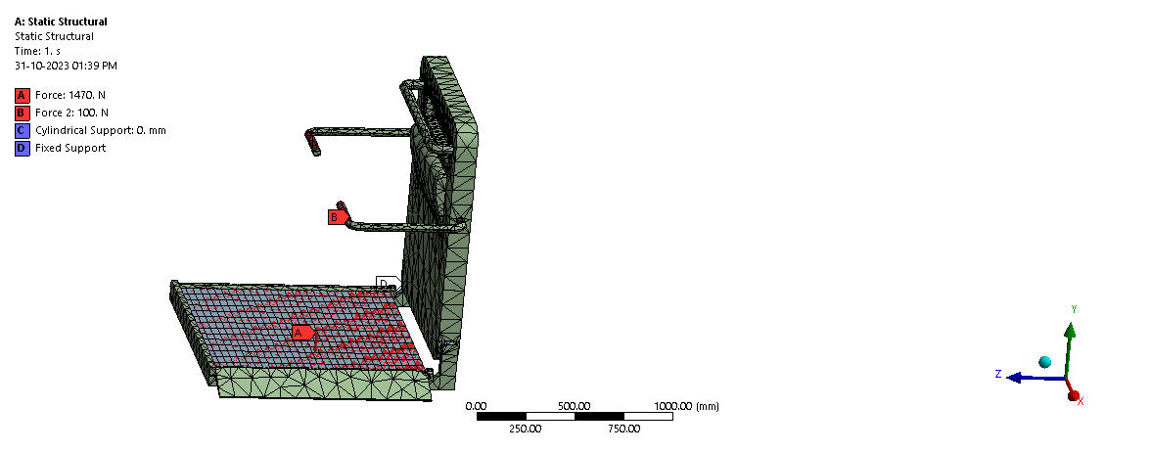

**RESULTS:**

**Total Deformation** refers to the overall displacement or distortion experienced by a structure or a component under applied loads. When engineers conduct a structural analysis, they use mathematical models and simulation techniques to predict how a structure will respond to external forces, such as loads or pressure.

**Deformation** is a measure of the change in shape or size of a structure when subjected to external loads. Total deformation encompasses both elastic deformation and plastic deformation. Here's a brief explanation of these terms:

**Elastic Deformation** is the temporary deformation that occurs when a material is subjected to stress. When the applied load is removed, the material returns to its original shape. The relationship between stress and elastic deformation is typically described by Hooke's Law.

**Plastic Deformation-** This is the permanent deformation that occurs when the applied stress exceeds a certain limit known as the yield strength of the material. Unlike elastic deformation, plastic deformation is not reversible, and the material undergoes permanent changes in shape.

Total deformation is the sum of both elastic and plastic deformations. It provides a comprehensive measure of how much a structure has deformed under the given loading conditions. Analyzing total deformation is crucial for ensuring that a structure remains within acceptable limits of displacement and doesn't exceed safety or performance criteria.

Engineers use various tools, such as finite element analysis (FEA), to simulate and analyze the total deformation of structures under different loading scenarios. This information is vital for optimizing designs, ensuring structural integrity, and meeting safety standards in various engineering applications.

**Von-Mises Stress-** The von Mises stress, named after Austrian physicist Richard von Mises, helps predict yielding in materials under various loads, particularly ductile materials like metals. This scalar value combines normal and shear stresses to predict yielding when it reaches a critical point compared to the material's yield strength. It's valuable when dealing with complex structures where a single value is crucial for predicting yield. Commonly used in FEA and simulations, it evaluates the structural integrity of components under complex loading conditions

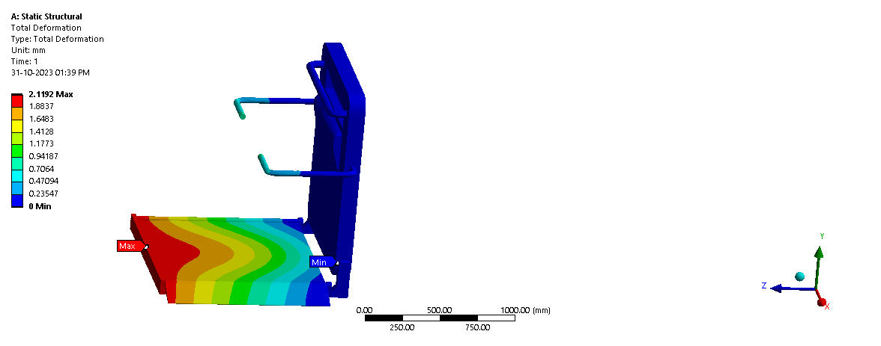**Total Deformation**:

**Figure 4.3.1**

* Here the Maximum Deformation that occurred is 2.1192mm.
* Here the Minimum Deformation that occurred is 0 mm

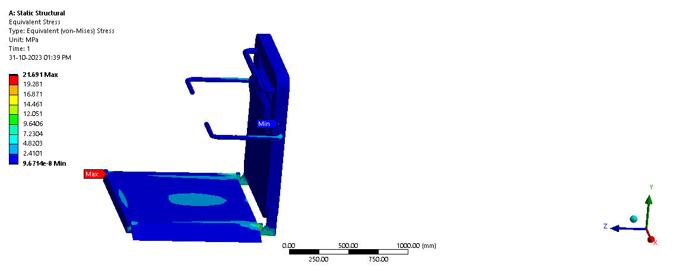**Figure 4.3.2**

**Von-Mises Stress.**

* Here the Max Von-Mises stress occurred is **21.691 MPA**
* The Min Von-Mises stress occurred is 9.6*108 MPA

**Explicit Dynamic Test.**

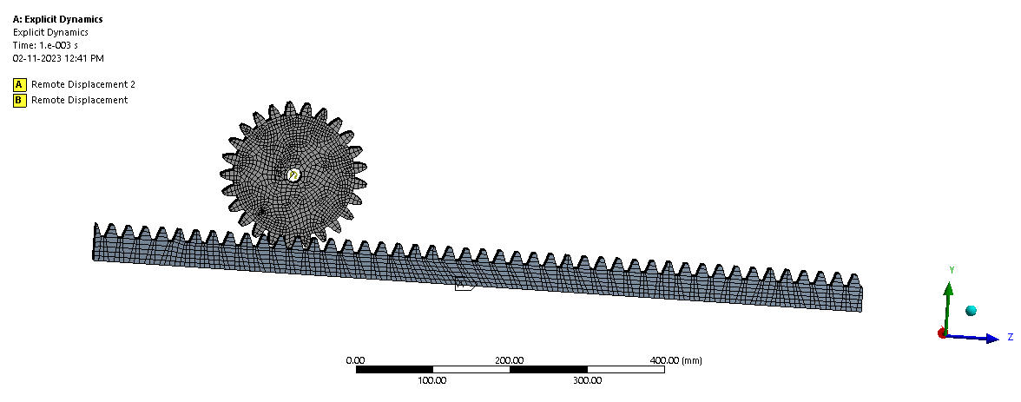**Figure 4.3.3**

**MESH.**

Here we carried out an Explicit Dynamic Test for the Rack and Pinion and the mesh properties with mesh size of 4 mm are

* **No of nodes = 19487**
* **No of elements=46136**

**Figure 4.3.4**

* We considered the velocity of the pinion **9.722 m/s.**
* Where the rack is fixed by keeping one axis free.

**TOTAL DEFORMATION**:

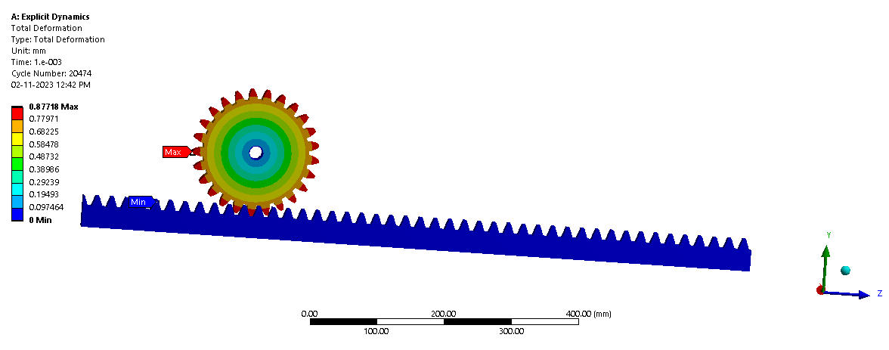**Figure 4.3.5**

* The maximum deformation that occurred for the test is 0.87718mm.
* The minimum deformation that occurred for the test is 0 mm.

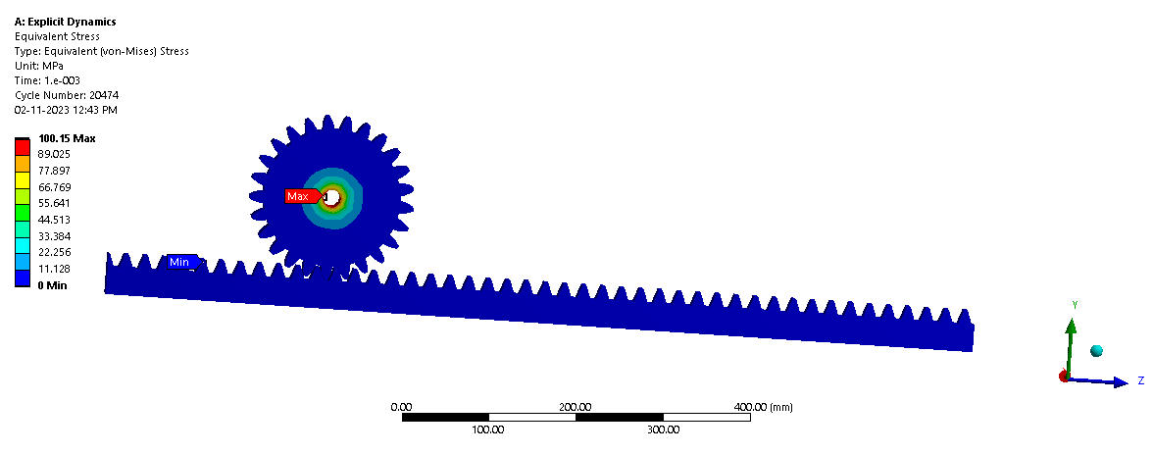**Figure 4.3.6**

**VON-MISES STRESS.**

* The max Von-mises stress that occurred for the test is 100.15 MPA.
* The min Von-mises occurred for the test is 0 MPA.

**STRAIN.**

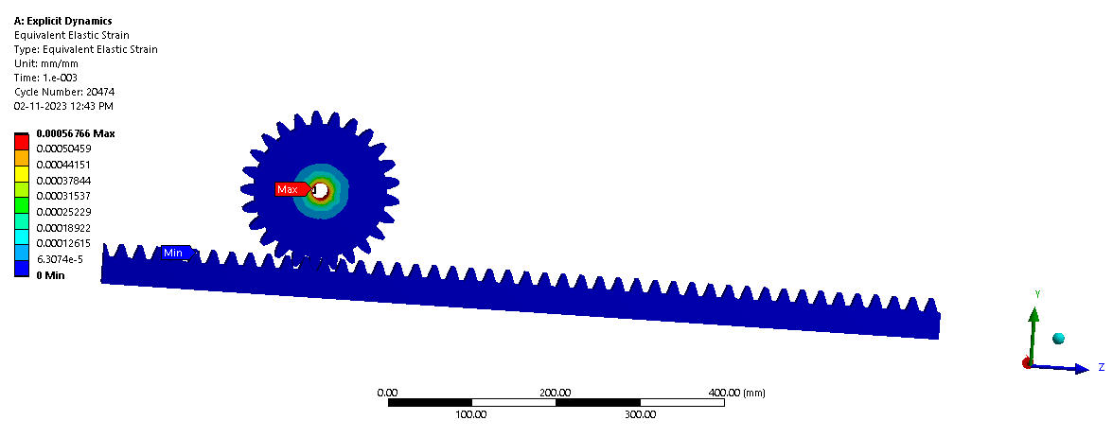**Figure 4.3.7**

* The max equivalent Elastic Strain that occurred for the impact test is 0.00056766mm/mm.
* The min equivalent Elastic Strain that occurred for the impact test is 0 mm/mm.

**Graphical Representation.**

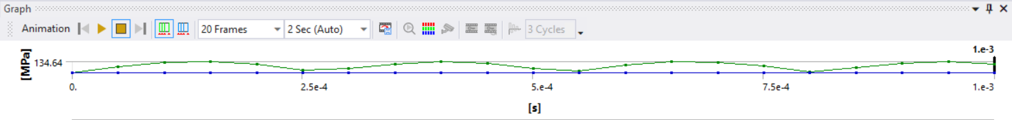

**Figure 4.3.8**

**2nd Iteration (Base Plate 10mm thickness)**

**Boundary Condition of Base Plate.**

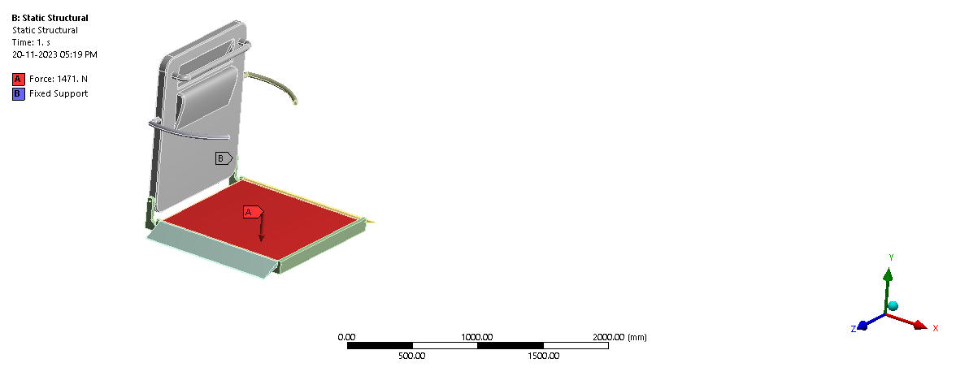

**Figure 4.3.9**

1. The total force applied on the base plate is 1470 N.

2. Fixed support given to the hinge

**Total Deformation.**

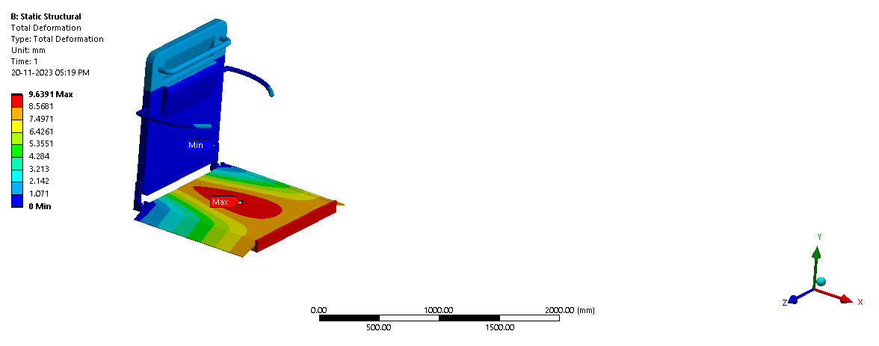

**Figure 4.3.10**

1. The maximum deformation that occurred for the test is 9.6391mm.
2. The minimum deformation that occurred for the test is 0 mm.

**Von-Mises Stress.**

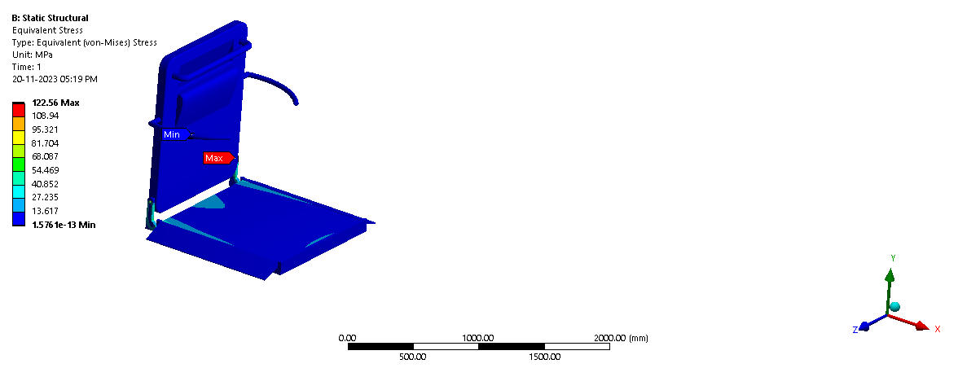**Figure 4.3.11**

* The max Von-mises stress that occurred for the test is 122.56 MPA
* The min Von-mises occurred for the test is 1.576e-13 MPA

**3rd Iteration (Base Plate thickness 8mm)**

**Boundary Condition of Base Plate.**

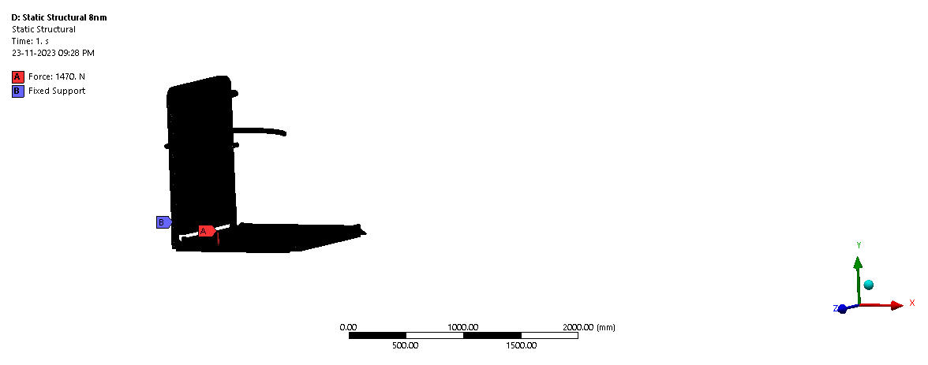**Figure 4.3.12**

1. The total force applied on the base plate is 1470 N.

2. Fixed support given to hinge.

**Total Deformation.**

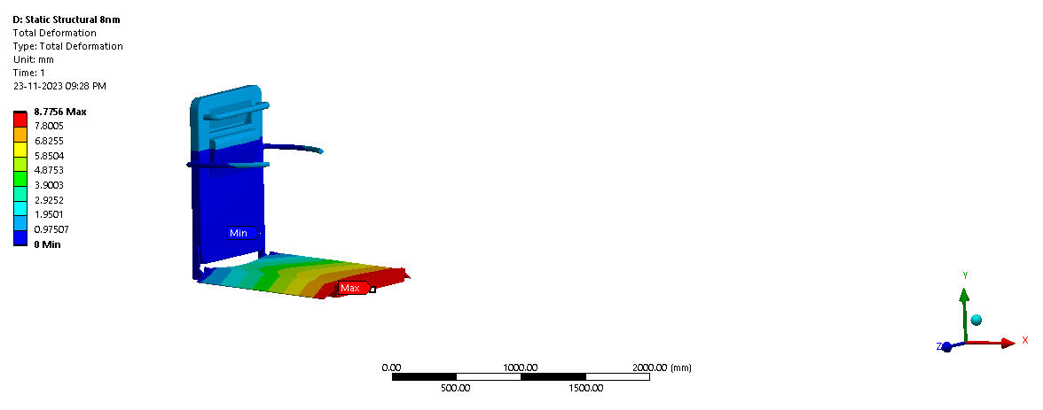

**Figure 4.3.13**

1. The max deformation that occurred for the test is 8.7756mm
2. The minimum deformation that occurred for the test is 0 mm

**Von-Mises Stress.**

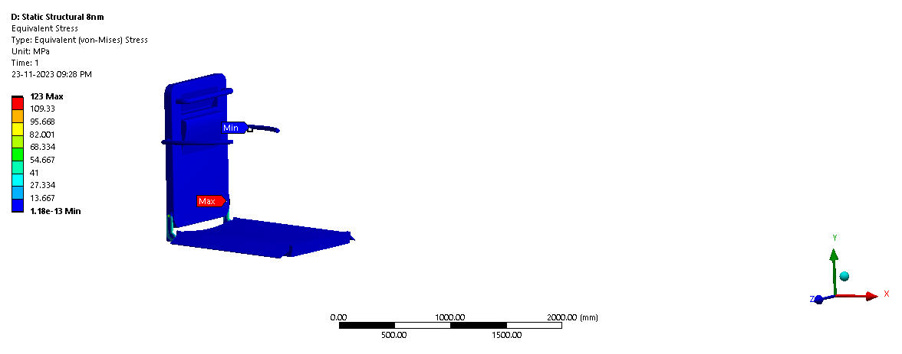

**Figure 4.3.14**

1. The maximum Von-mises stress that occurred for the test is 123 MPA
2. The minimum Von-mises occurred for the test is 1.18e13 MPA

**4th Iteration (Base Plate thickness 12mm)**

**Boundary Condition of Base Plate.**

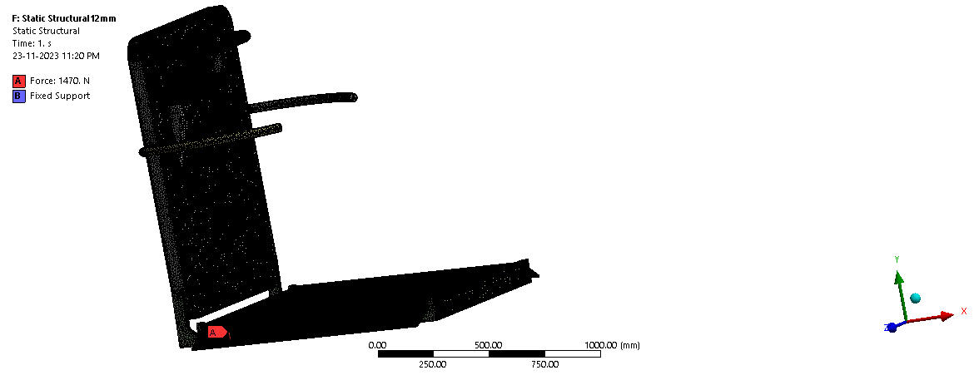

**Figure 4.3.15**

1. The total force applied on the base plate is 1470 N.

2. Fixed support given to hinge.

**Total Deformation.**

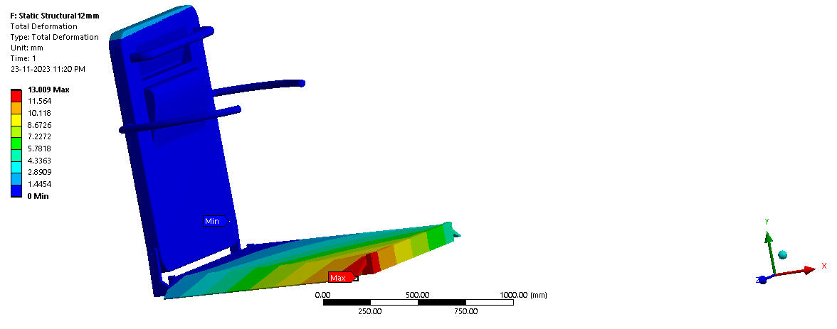**Figure 4.3.16**

1. The max deformation that occurred for the test is 13.009mm.

2. The min deformation that occurred for the test is 0 mm.

**Von-Mises Stress.**

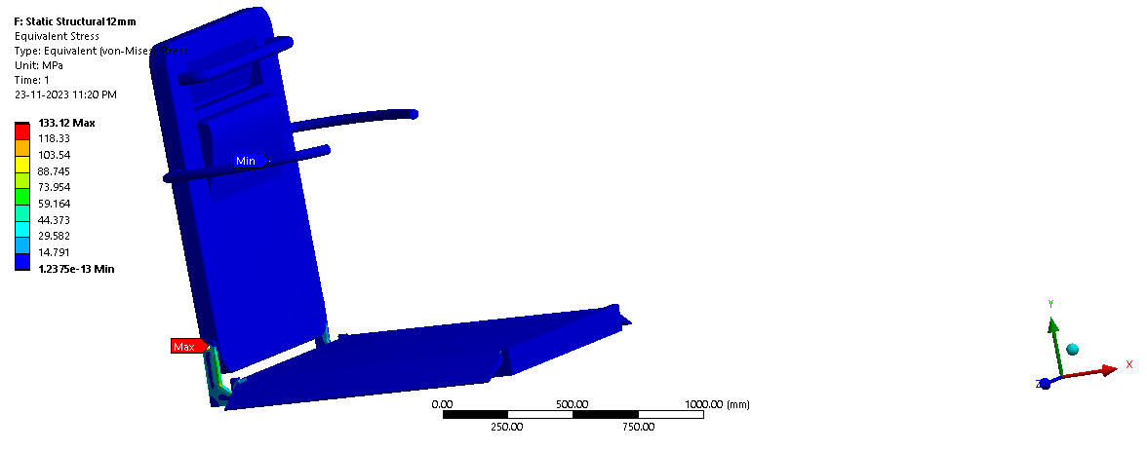**Figure 4.3.17**

1. The max Von-mises stress that occurred for the test is 133.12 MPA

2. The min Von-mises occurred for the test is 1.2375e^13 MPA

**Handle Analysis Boundary Conditions.**

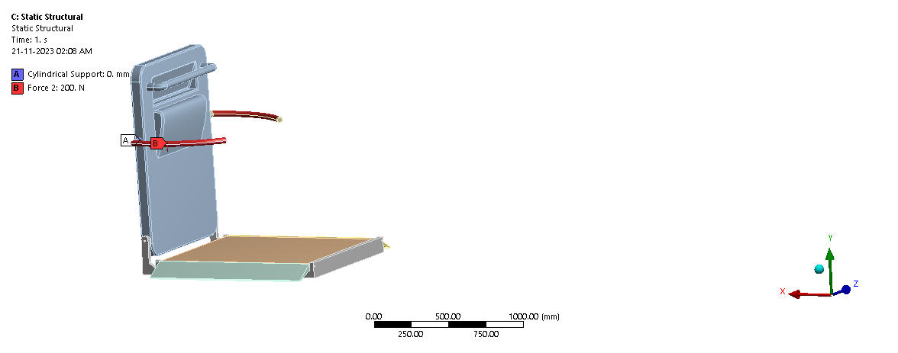**Figure 4.3.18**

1**.** Handles are fixed with cylindrical support.

2. A force of 200N is applied to the handle in a downward direction.

**Total Deformation.**

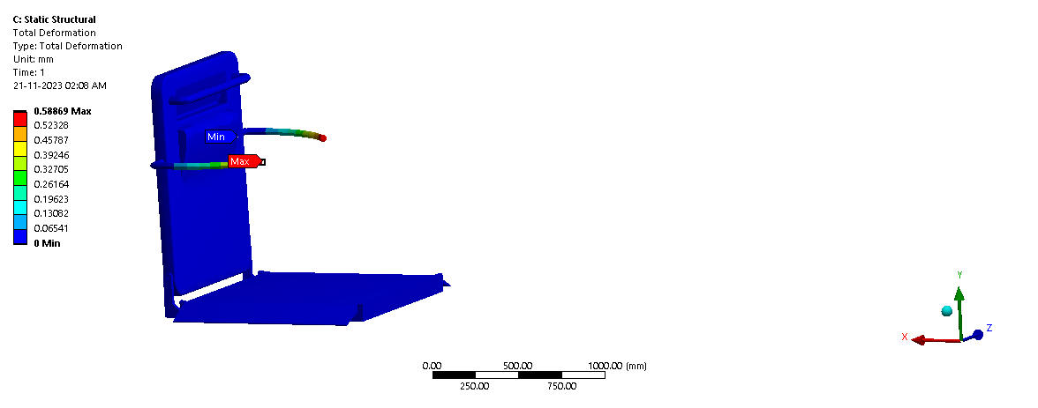

**Figure 4.3.19**

1. The max deformation that occurred for the test is 0.58869mm.
2. The minimum deformation that occurred for the test is 0 mm.

**Von-Mises Stress.**

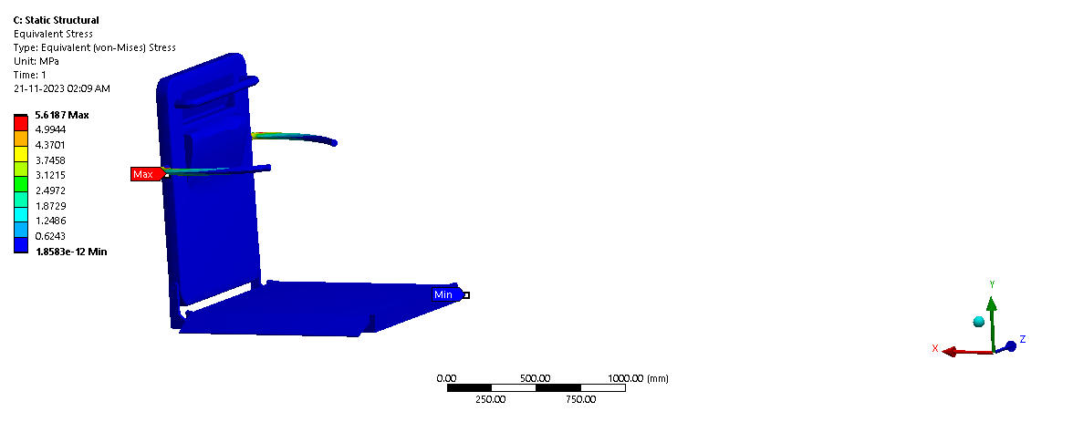**Figure 4.3.20**

1. The max Von-Mises stress that occurred for the test is 5.6187 MPA
2. The min Von-mises occurred for the test is 1.8583e^-12 MPA

**Handle Analysis Boundary Conditions.**

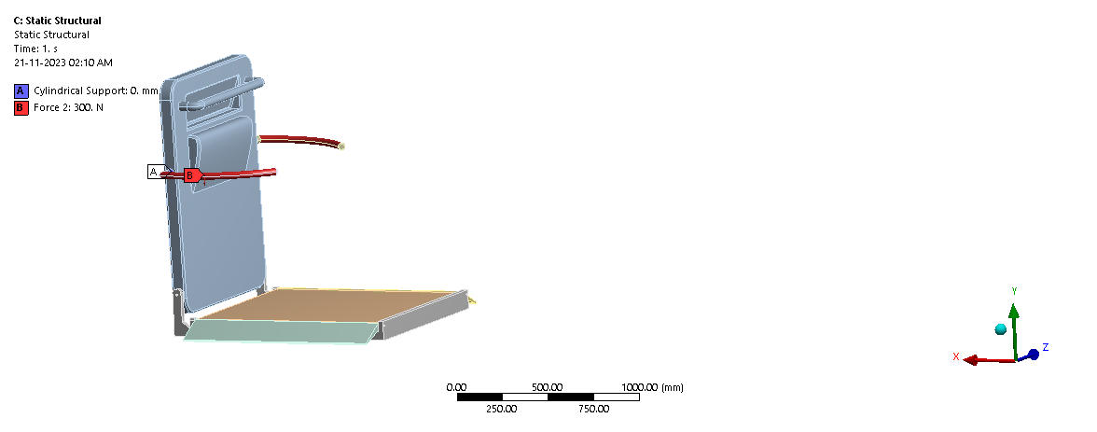**Figure 4.3.21**

1. Thehandles are fixed with cylindrical support.

2. A force of 300N is applied to the handle in a downward direction.

**Total Deformation.**

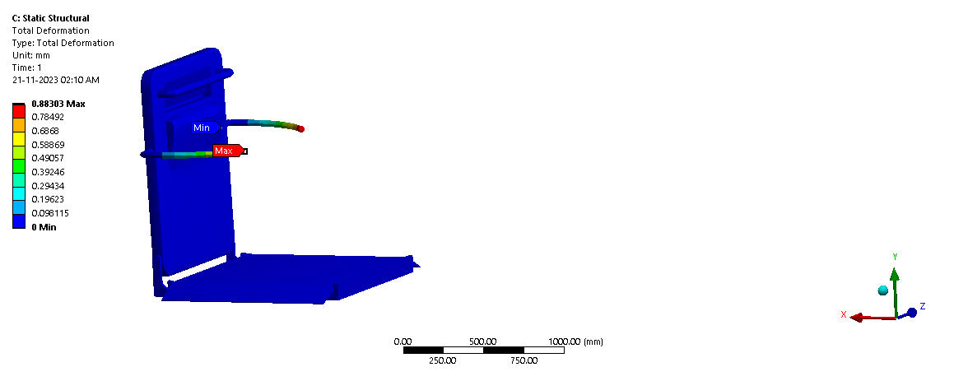**Figure 4.3.22**

1. The max deformation that occurred for the test is 0.58869 mm.

2. The min deformation that occurred for the test is 0 mm.

**Von-Mises Stress.**

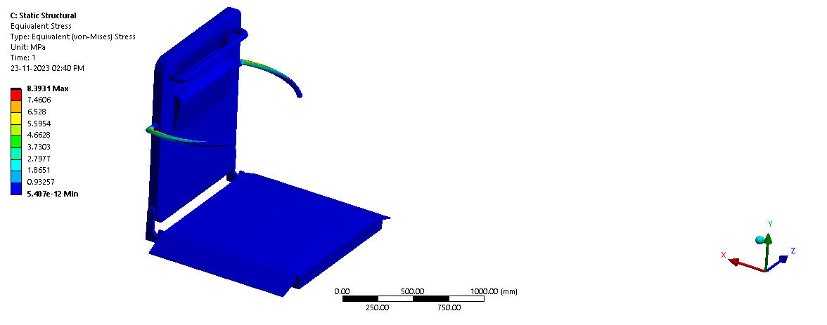**Figure 4.3.23**

1. The max Von-mises stress that occurred for the test is 8.3931 MPA

2. The min Von-mises occurred for the test is 5.407e^-12 MPA

**Selected FEA Analysis/Design**

**1st Iteration (Base Plate 10mm thickness)**

**Boundary Condition of Base Plate.**



**Figure 4.3.24**

1.The total force applied on the base plate is 1470 N.

2.Fixed support given to hinge.

**Total Deformation**.



**Figure 4.3.25**

1. The max deformation that occurred for the test is 9.6391mm.

2. The min deformation that occurred for the test is 0 mm.

**Von-Mises Stress.**



**Figure 4.3.26**

1. The max Von-mises stress that occurred for the test is 122.56 MPA

2. The min Von-mises occurred for the test is 1.576e-13 MPA

# 

# 5. Conclusion

# The design and modelling of a staircase-assisted climber proved the viability of developing a safe, dependable, and user-friendly technology to assist people with mobility issues in ascending steps.

# The project effectively analysed the climber's movement, forces, and stresses during operation using 3D modelling, kinematic and dynamic analysis, and stress analysis methods, assuring structural integrity and operational efficacy.

# The climber's future development might concentrate on improving portability, adding safety measures, and refining user interface design for better accessibility and simplicity of usage.

# Staircase-assisted climbers have the potential to become a vital tool for enhancing mobility and independence for those with impairments and the elderly as technology and manufacturing processes progress.

# 6. Future Scope

**Enhanced mobility for disabled and elderly**: Staircase-assisted climbers offer a safe and effortless way for people to navigate multiple floors independently.

**Future advancements**: Possibilities include voice control, obstacle recognition, automated docking, smart home integration, and flexible scheduling.

**Improved portability**: Future designs could be lighter and more compact for easier transportation.

**Advanced control options**: Voice and gesture recognition could make climbers more accessible for people with restricted mobility.

**Reduced cost**: As manufacturing techniques improve, the cost of these devices is expected to decrease.

# 7. References

1. "Design and Analysis of a Staircase Climbing Robot for Disabled People" by M.A. González-Morgado et al., International Journal of Advanced Robotic Systems, Vol. 10, No. 3, pp. 1-10 (2013)

2. "Development of a Stair Climbing Robot for People with Disabilities" by S.A.H. Hashemi et al., IEEE/ASME Transactions on Mechatronics, Vol. 21, No. 3, pp. 867-876 (2016)

3. “Design and Analysis of a Stair-Climbing Robot for Elderly and Disabled People" by M.A. Gonzalez-Pino, M. Sandoval, and A.J. Gonzalez-Mendez (2016)

4.h[ttps://www.academia.edu/1147760/Design_and_Implementation_of_Stair_Climbing_Robot_for_Rescue_Applications](https://www.academia.edu/1147760/Design_and_Implementation_of_Stair_Climbing_Robot_for_Rescue_Applications)

5. Liu Haixia's "Thirteenth Five-Year Plan for Healthy Aging" is issued and my country will build a health service system for the elderly[J]. Chinese Medical Information Guide, 2017 (6)

6. Liu Dongfang. Analysis of the interface design of the elderly website[J]. China Water Transport. 2007. (9): 56-60

7. Lei Hongchun, Zhao Tong, Yang Baoyuan, et al. Design of a convenient wheelchair up and down stairs[J]. Electronic World, 2019(20):162-163.

8. Zhang Tie, Cai Chao. Research on Constant Force Control of Robot Lapping System on Floating Platform [J]. Machinery Design & Manufacture, 2019(6): 150-156.